

Main report submitted to
the Department of Computer Engineering of Çankaya University
in partial fulfilment of the requirement for
CENG 505 Parallel Computing I
Term Project

CENG 505 Parallel Computing I

TERM PROJECT

By

200972001Funda KARABAK

Date: 21/01/2011

HONOR CODE

I hereby declare that, except where I have indicated, the work I am submitting in this report is my own work.

STUDENT NAME | SIGNATURE
Funda KARABAK

TABLE OF CONTENTS

1. BRANCH AND BOUND ALGORITHM 3
2. THE PARALLELIZATION OF BRANCH AND BOUND ALGORITHM 4
3. CONCLUSION 7
4. REFERENCES 8

LIST OF FIGURES

Figure-1 Branch and Bound Algorithm Scheme 4
Figure-2 Parallelization of Branch and Bound Algorithm on MPI (master) 6
Figure-3 Parallelization of Branch and Bound Algorithm on MPI (Slave) 7

1. BRANCH AND BOUND ALGORITHM

The Branch and Bound algorithm is an general algorithm to find optimal solutions of hard optimization problems. It finds the optimum solution of a problem through a selective exploration tree. The nodes of tree show that different states of the solution states for solution search.

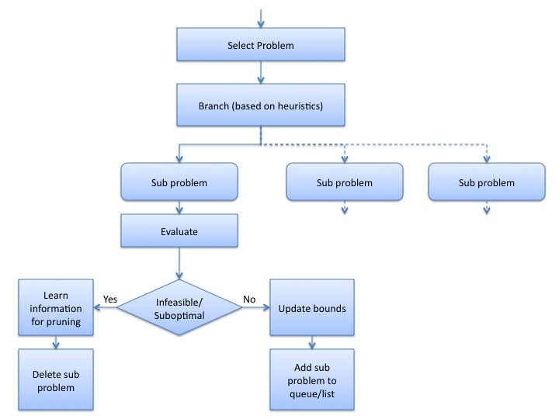

Figure-1 Branch and Bound Algorithm Scheme [2]

Figure-1 shows that there is a selected problem. And selected problem is branched to sub problems.

First idea of the algorithm is to construct predictor of the likelihood of a node in the solution tree. This predictor will lead to an optimal solution.

And the algorithm works as:

- Which node to branch next: The algorithm selects the live node with the best predictor value. Phase 1 shows this step in the Figure-1.

- After selecting the branching node, the algorithm simply branches that node. This means that it generates all its children. The phase 2 shows this step in Figure-1.

- Then, the predictor value of all newly constructed node is calculated. Here it is important that the branched node is known as dead node, and the children of this node is called as live nodes.

- After creating all children, the best node is chosen based on the upper and lower bounds of the branched problem.

2. THE PARALLELIZATION OF BRANCH AND BOUND ALGORITHM

Parallelization is used for Branch and Bound Algorithm, because;

- Many applications that appropriate B&B are highly computationally dense. Hence by using parallelization, algorithm can benefit from multiple computers to improve their performance.
- An implemantation following this norm can be divided into large numbers of subproblems. (tasks)
- Each of those tasks are highly asynchronous and self-contained.
- There is limited communication between these tasks.
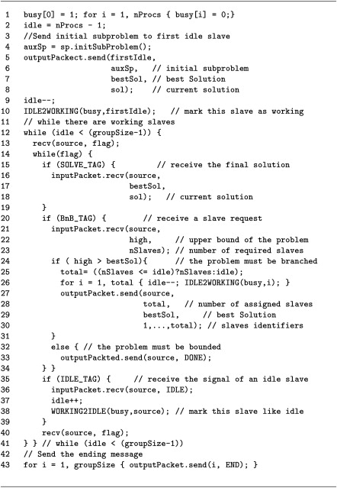

Figure-2 Parallelization of Branch and Bound Algorithm on MPI (master) [1]

Figure-2 shows the parallelization of the algorithm for Knapsack problem using MPI. It shows tasks for the Master. Here, generation of new subproblems and the evaluation of the results of each of them are completely separated of the individual processing of each subtask. The Master is responsible of the coordination between subtasks. At the beginning all th slaves are idle. The initial subproblem, the best solution and the best value of the objective function are sent to an idle slave. While there are idle slaves the Master receives information from them and decides the next step if the problem is solved. If it is so, the solution is received and stored. When the master receives a request of certain number of slaves, it is followed by the upper bound value. If the upper bound value is better than the actual value of the best solution, the answer to slave includes the number of slaves that can help to solve its problem. In other case the answer indicates that it is not necessary to work in this subtree. When the number of idle slaves is equal to the initial value, the search process finishes, then the master informs the slaves to end the work.
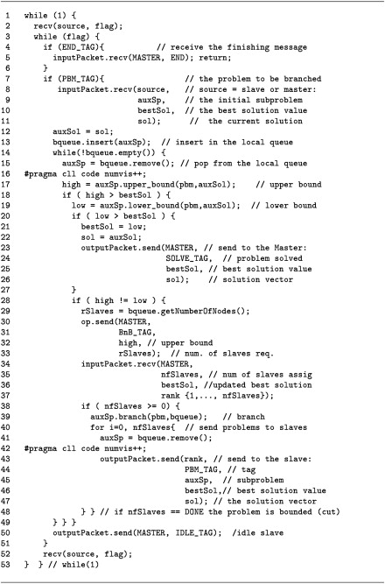

Figure-3 Parallelization of Branch and Bound Algorithm on MPI (Slave) [1]

In figure-3, A slave works bounding the received problem. New subproblems are generated by calling the branch method. The slave asks for the help to Master. If no free slaves are provided, the slave continues working locally. Otherwise. It removes subproblems from its local queue and sends them directly to other slaves.

3. CONCLUSION

Here, the Branch and bound algorithm for the Knapsack problem is investigated. For example the experiments are done on three different machines; Sunfire 6800 SMP, Origin 3000 and heterogeneous cluster of PCs. Results of the parallelization in Branch & Bound algorithm can be seen in Table 1, 2 and 3. According to these tables, it can be said that on different machines and on different numbers of processors computation time changes.
Table 1. MPI Implemetation, Sunfire 6800 SMP[3]
Procs | Avg | Min | Max | SpeedUp Avr
2 | 1560 | 1554 | 1569 | 0,98
3 | 1185 | 1177 | 1204 | 1,29
4 | 767 | 625 | 896 | 1,99
8 | 412 | 378 | 462 | 3,71
16 | 303 | 284 | 315 | 5,04
24 | 250 | 239 | 258 | 6,12
Sunfire 6800 SMP, the sequanltial average time is 1529 sec.

Table 2. MPI Implemetation, Origin 3000[3]
Procs | Avg | Min | Max | SpeedUp Avr
2 | 933 | 932 | 933 | 0,93
3 | 743 | 740 | 745 | 1,17
4 | 454 | 399 | 492 | 1,91
8 | 251 | 236 | 266 | 3,44
16 | 186 | 174 | 192 | 4,66
24 | 152 | 144 | 167 | 5,69
32 | 151 | 144 | 166 | 5,74
Origin 3000, the sequanltial average time is 867 sec.

Table 3. MPI Implemetation, Cluster of PCs[3]
Procs | Avg | Min | Max | SpeedUp Avr
2 | 11390 | 11343 | 11434 | 0,47
3 | 9344 | 6175 | 10044 | 0,57
4 | 5162 | 4538 | 6195 | 1,04
8 | 3772 | 3478 | 4642 | 1,44
10 | 3518 | 3299 | 3699 | 1,52

Cluster of PCs, the sequanltial average time is 5357 sec

4. REFERENCES

- http://ditwww.epfl.ch/SIC/SA/publications/SCR94/6-94-page15.html#3

- http://www.mutah.edu.jo/userhomepages/CS252/branchandbound.html

- Dorta I., Leon C., Rodriguez C.: A Comparison Between MPI and OpenMP Branch and Bound Skeletons. IPDPS '03 Proceedings of the 17th International Symposium on Parallel and Distributed Processing,0-7695-1926-1, 2003

- Hönig U., Schiffmann W.: A Parallel Branch and Bound Algorithm for Computing Optimal Task Graph Schedules. Grid and Cooperative Computing, Second International Workshop, GCC, 2003

